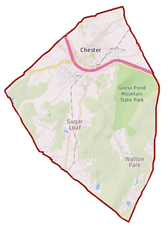
Town of Chester
Zoning Board of Appeals

1786 Kings Highway
Chester, NY 10918
(845) 469-7000 x338

Chairman: Gregg Feigelson

Members: Julie Bell
Dan Doellinger
Bob Favara
Walter Popailo
Alternate: Tom Atkin

Attorney: Robert Dickover
Secretary: Julie Tiller

Agenda MEETING CANCELLED
Oct. 8, 2020 |  | 7:00 PM |  | Location: Zoom Teleconference  Information below
Time | Item
7:00 PM | Pledge of allegiance
 | Adoption of minutes |  | (as applicable)
 | Other business |  | (as applicable)
 | Item |  | Applicant / Address / Zone |  |  | Summary
Join Zoom Meeting

